**Chapter 3**

**Vector-Valued Functions**

**3.3 Arc Length and Curvature**

**Section Exercises**

**Find the arc length of the curve on the given interval.**

103. 

Answer: 

105. 

Answer: 

107. Find the length of one turn of the helix given by 

Answer: Length

109. A particle travels in a circle with the equation of motion  Find the distance traveled around the circle by the particle.

Answer: 

111. Find the length of the curve  over the interval  The graph is shown here:

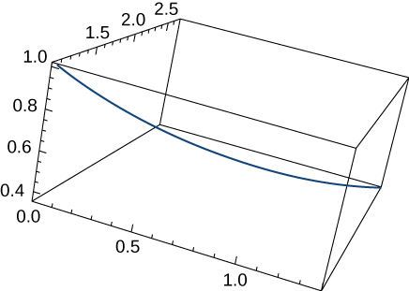

Answer: 

113. The position function for a particle is  Find the unit tangent vector and the unit normal vector at 

Answer:  

115. Given  determine the unit tangent vector 

Answer: 

117. Given  find the unit normal vector  evaluated at  

Answer: 

119. Given  find the unit tangent vector  The graph is shown here:

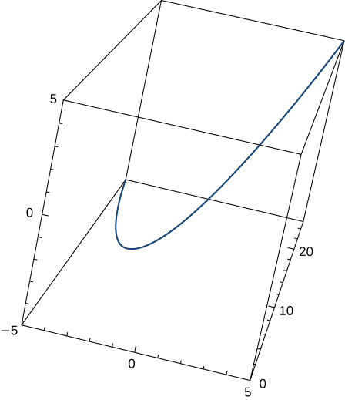

Answer: 

121. Find the unit tangent vector  for 

Answer: 

123. Find  for the curve 

Answer: 

125. Find the unit normal vector  for 

Answer: 

127. Find the arc-length function  for the line segment given by  Write *r* as a parameter of *s.*

Answer: Arc-length function:  r as a parameter of *s*: 

129. Parameterize the curve using the arc-length parameter *s*, at the point at which  for 

Answer: 

131. Find the *x*-coordinate at which the curvature of the curve  is a maximum value.

Answer: The maximum value of the curvature occurs at 

133. Find the curvature  for the curve  at the point 

Answer: 

135. Find the curvature  of the curve  The graph is shown here:

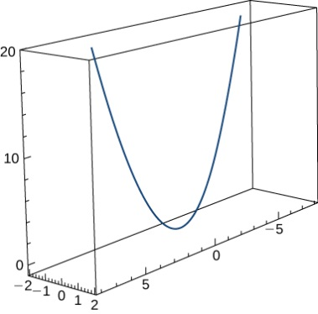

Answer: 

137. Find the curvature of  at point 

Answer: 

139. What happens to the curvature as  for the curve 

Answer: The curvature approaches zero.

141. Find the equations of the normal plane and the osculating plane of the curve  at point 

Answer:  and 

143. Find the equation for the osculating plane at point  on the curve 

Answer: 

145. Find the curvature at each point  on the hyperbola 

Answer: 

147. Find the radius of curvature of  at point 

Answer: 

**A particle moves along the plane curve C described by  Solve the following problems.**

149. Find the length of the curve over the interval 

Answer: 

151. Describe the curvature as *t* increases from  to 

Answer: The curvature is decreasing over this interval.

**The surface of a large cup is formed by revolving the graph of the function  from  to  about the *y*-axis (measured in centimeters).**

153. Find the curvature  of the generating curve as a function of *x.*

Answer: 

This file is copyright 2016, Rice University. All Rights Reserved.